IOT BASED FLOOD MONITORING

AND

EARLY WARNING

**A project report submitted in partial fulfilment Of the requirments for the degree of B.E in COMPUTER SCIENCE AND ENGINEERING**

BY

S.Sushmitha(513221104025)

phase 4 project submission

INTRODUCTION

Amongst natural disasters, floods represent one of the great global challenges harming humankind.This phenomenon leaves tens of thousands of victims worldwide. In terms of lives lost and propertydamaged, floods are ranked just behind tornadoes as the top natural disaster in the United States.According to studies by the United Nations Office for Disaster Risk Reduction (UNDRR) [**[1](https://www.mdpi.com/1424-8220/20/18/5231#B1-sensors-20-05231)**], since1995, floodsrepresented47%ofall weather-relateddisastersandarecontinuouslylisted firstamong natural disasters worldwide. In recent years (2008–2017), approximately 73.1 million peoplewere affected by floods. The total number of people affected grew significantly in 2018 to 34.2million people [**[2](https://www.mdpi.com/1424-8220/20/18/5231#B2-sensors-20-05231)**]. The data show a trend that the number and severity of floods may be increasing,thus making it more important for persons to better anticipate floods, according to experts withinthe United Nations Climate Change Conference (COP21). As the phenomenon of a dynamic range ofenergy in weather systems increases, effects are increasingly noticeable in the hydrological cycle andassociatedriversystemcatchmentareas.

Flood prediction models may be tuned using historical hydrological data concerning fluvial floods[**[3](https://www.mdpi.com/1424-8220/20/18/5231#B3-sensors-20-05231)**[,](https://www.mdpi.com/1424-8220/20/18/5231#B4-sensors-20-05231)**[4](https://www.mdpi.com/1424-8220/20/18/5231#B4-sensors-20-05231)**]. However, due to climate change and the increased levels of energy in weather systems, flashflooding is becoming more common and therefore, when considering flood alerting systems,historical data are less useful than real-time data [**[5](https://www.mdpi.com/1424-8220/20/18/5231#B5-sensors-20-05231)**[,](https://www.mdpi.com/1424-8220/20/18/5231#B6-sensors-20-05231)**[6](https://www.mdpi.com/1424-8220/20/18/5231#B6-sensors-20-05231)**]. Flash floods concentrate their waters in smallgeographic areas within six hours of the rains or other events that spawned them and arecharacterized by a rapid rise of fast-moving water. Water moving at 10 m per second, a commonspeed for flash floods, can move rocks weighing almost a hundred pounds. Flash floods carry debristhatelevatestheir potential todamagestructures andinjure people.

(1)

InternetofThings(IoT)technologyineachofthe nodes.

(2)

LORA (LOng RAnge) technology to communicate between drifters, RiverCore nodes, and thehardwarelocated inthe sniffer.

(3)

MQTT (MQ Telemetry Transport) protocol to carry out the communication between the fixedand mobile nodes with the server in the cloud, making efficient handling of data acquisition.(4)

JSON (JavaScript Object Notation) protocol for data exchange.(5)

LowEnergyConsumptionTelemetry.

1. MaterialsandMethods

The components of the system include a fixed node (RiverCore), a mobile node(Drifter), a drone mountable sniffer, and weather stations, along with a web-based data acquisition platform, all integrated with IoT techniques to retrievedatathrough3Gcellularnetworks.

The developed architecture uses the Message Queuing Telemetry TransportProtocol (“MQTT is an OASIS standard messaging protocol for the Internet ofThings (IoT)” [[17](https://www.mdpi.com/1424-8220/20/18/5231#B17-sensors-20-05231)]), to send real-time data packages from fixed nodes to aserverthatstoresretrieveddatainanon-relationaldatabase.Fromthis,data

can be accessed and displayed through different customizable queries andgraphical representations, allowing future use in flood analysis and predictionsystems.Theparts ofthesystemcanbeseen in[Figure1](https://www.mdpi.com/1424-8220/20/18/5231#fig_body_display_sensors-20-05231-f001).

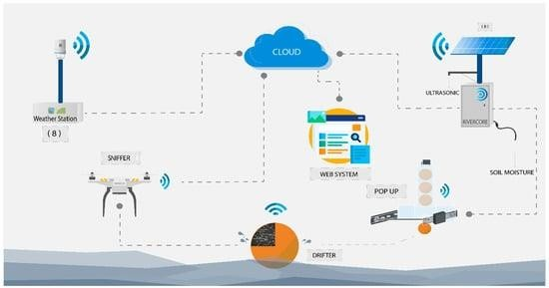

**Figure1.**Elementsoftheearlywarningsystem(RiverCore,weatherstation,drifter,and sniffer).

* 1. SystemComponents

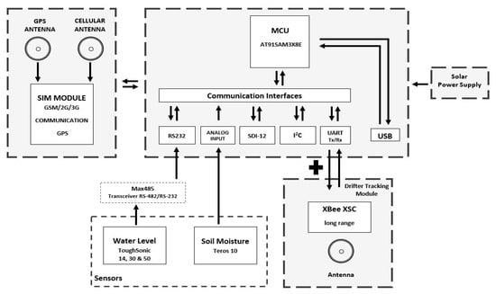

**Figure2.**RiverCorehardwareblockdiagram.

TheRiverCorefixednodeisphysicallycomposedofa32-bitmicrocontroller unit, a 3G cellular modem electronic board, an XBee (802.15.4)(“modulesseamlesslyinterfacewithcompatiblegateways,deviceadaptersand

rangeextenders,providingdevelopers withtruebeyond-the-horizon

connectivity.” [**[19](https://www.mdpi.com/1424-8220/20/18/5231#B19-sensors-20-05231)**]), or LoRa radio, shield/daughterboard, an RS-485 transceiver, a regulatedpower supply,a solarchargecontroller, anda12v80Ahbattery.

* + - Radiolinkbudgets
      * XBEEXSCPRO
        + Transmitpower20dBm.
        + Receiversensitivity−106dBm.
        + SpreadspectrumFHSS.
        + Outdoor/line-of-sightrange6mi.
        + Urbanrange 1200 ft.
      * SIM5320A
        + Receivesensitivity−106dBm.
        + Transmissionpower33dBm.

The weather station will be an important part of the forecasting model inthe future, adding the variables it measures to be able to predict floods withmoretime.

It is intended to study the variables and compare them with the historicaldata of past hurricanes that have caused the overflow of rivers in the city. Theyare presented as part of the early warning system solution so that it is fullyknown.

This node (diagram shown in **[Figure 3](https://www.mdpi.com/1424-8220/20/18/5231#fig_body_display_sensors-20-05231-f003)**) integrates a series of electroniccomponents that the ATMOS 41 (all-in-one weather station [**[20](https://www.mdpi.com/1424-8220/20/18/5231#B20-sensors-20-05231)**]) weatherstation employs. Its high-performance, low-power Microchip 8-bit AVR RISC-based microcontroller handles the data of the 12 weather sensors included onATMOS 41. The data are packed and sent to the platform via a wired internetconnection. They also get stored with a timestamp on a Micro SD card as abackup.

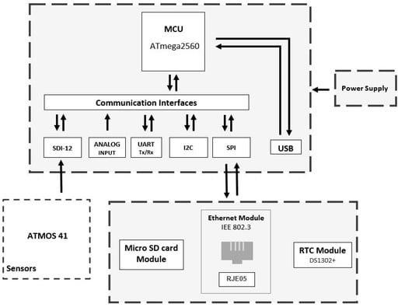

**Figure3.**Weatherstationhardware blockdiagram.

* + - WeatherStationSpecifications

Solar radiation: Range: 0 to 1750 W/m2; resolution: 1 W/m2; accuracy: ±5% of typicalmeasurement.

Precipitation:Range:0to400mm/h;resolution:0.017mm;accuracy:±5%of

measurementfrom0to50mm/h.

Vapor Pressure: Range: 0 to 47 kPa; resolution: 0.01 kPa; accuracy: varies withtemperatureandhumidity,±0.2kPatypicallybelow40 °C.

Relative Humidity: Range: 0 to 100% RH (0.00–1.00); resolution: 0.1% RH; accuracy:varies withtemperatureandhumidity,±3%typical RH.

Airtemperature:Range:−50to60 °C;resolution:0.1 °C;accuracy:±0.6°C.

Humiditysensortemperature:Range: −40to50°C;resolution:0.1°C;accuracy:±1.0

°C.

Barometricpressure:Range:50to110kPa;resolution:0.01kPa;accuracy:±0.1kPa

from−10to50°C,±0.5 kPa from −40to60°C.

Horizontalwindspeed:Range:0to30m/s;resolution:0.01m/s;accuracy:greaterthan

0.3m/sor3%ofmeasurement.

Windgust:Range:0to30 m/s;resolution:0.01m/s;accuracy:greaterthan0.3m/sor3%ofmeasurement.

Winddirection:Range: 0°to359°; resolution:1°;Accuracy:±5°

Tilt:Range:−90°to +90°;resolution:0.1°;accuracy: ±1°.

Lightningstrikecount:Range:0to65,535strikes;resolution:1strike;accuracy:variablewithdistance,>25%detectionat<10 kmtypical.

Lightningaveragedistance:Range:0to40km;resolution:3km;accuracy:variable

[**[20](https://www.mdpi.com/1424-8220/20/18/5231#B20-sensors-20-05231)**].

Drifter—Afree-floatingsensorthattakeslocalmeasurementsandtrackstheflowin

water systems. Drifters compile water measurements to estimate the flow of ahydrodynamic system; however, it requires communication capabilities and a method tointegratethegathereddata intoanappropriatedatastructure.

Thedrifterarchitecture(**[Figure4](https://www.mdpi.com/1424-8220/20/18/5231#fig_body_display_sensors-20-05231-f004)**)includesaradiotocommunicatelocationinformationtothefixednodeandRiverDrone(sniffer),therebyincreasingthepossibilitiesof finding and recovering them. It also incorporates an SD card module to store the location,speed, and potentially, any other data that are registered. Importantly, it can be equippedwithadditionalmodulesorsensors.Thesystemrecoverymethodisexplainedin**[Section3.2](https://www.mdpi.com/1424-8220/20/18/5231#sec3dot2-sensors-20-05231)**.

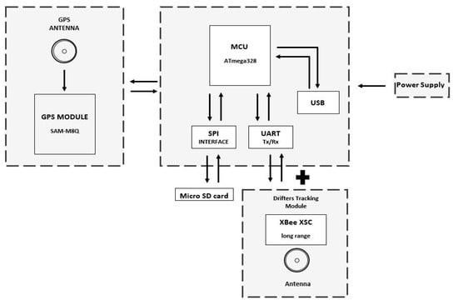

**Figure4.**Drifter hardwareblockdiagram.

The sniffer architecture (**[Figure 5](https://www.mdpi.com/1424-8220/20/18/5231#fig_body_display_sensors-20-05231-f005)**) allows the device to work as a sniffer looking fordrifters.Equippedwithmatchingradio,cellularcommunication,andGPS,drifterscanreporttheir location to the EWIN platform, where the information is forwarded and displayed on aweb page.

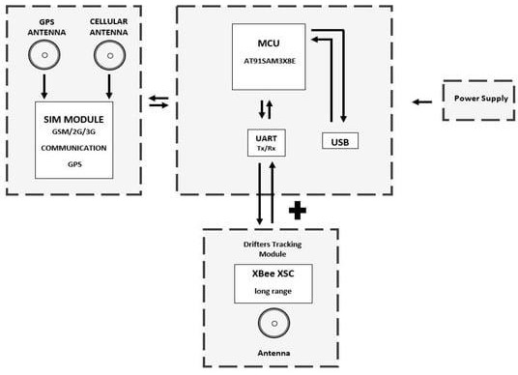

**Figure5.**Snifferhardwareblockdiagram.

* 1. **HardwareDevelopment**

Hardware requirements have been defined according to thespecific needs of the application, which has resulted in thedevelopment of fixed, weather station nodes, and drifter nodes,alongwithadataacquisitionprocessthatusesIoTtechniquestoretrievedatathroughthe3Gcellularnetwork.

Power management, the cellular communication method, andother components described in a previous paper [**[21](https://www.mdpi.com/1424-8220/20/18/5231#B21-sensors-20-05231)**] remainunchanged.Theirinitialdesigneffectivelyhandlestheextraloadanddemands of the new hardware now incorporated on the fixed node.Themainhardwaremodulesor thefixed node c

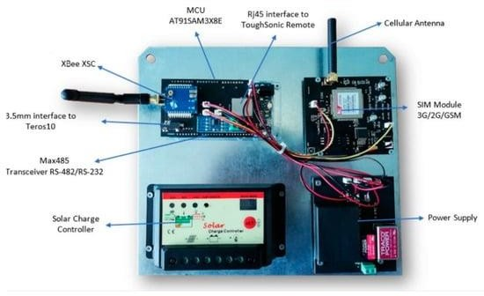anbe

seenin **[Figure6](https://www.mdpi.com/1424-8220/20/18/5231#fig_body_display_sensors-20-05231-f006)**[.](https://www.mdpi.com/1424-8220/20/18/5231#fig_body_display_sensors-20-05231-f006)

**Figure6.**RiverCorehardwaremodules.

* 1. SensorandProcessingConsiderations

The ultrasonic water level sensors ToughSonic Remote 14, 30, and 50 areused to measure the distance between the water surface and the sensorlocation. The data generated are then processed within the microcontrollerandencapsulatedinaJSON(“JavaScriptObjectNotationisalightweightdata

exchange format”) structure, along with an identification string. These data arethen transmitted to the server through the 3G cellular network and stored intothe NoSQL (“No Structured Query Language”) database to carry out futurecalculationsthatcanlater beusedforfloodforecasting.

Several versions of this sensor are available, each of which possessdifferent ranges and communication interfaces. Three different models wereconsidered (ToughSonic Remote 14, 30, and 50), each with a different range,although all of them communicate through the RS-485 standard. The RiverCoreprocessor board does not support this standard. Consequently, a Max 485transceiver was employed to handle the communication between themicrocontroller and the sensor. Before connecting to RiverCore, each sensorneedstobeconfiguredemployingthemanufacturer’ssoftware,ASCII

(“AmericanStandardCodeforInformationInterchange”)streaming,witha

57,600baudrate,whichis thedefaultconfigurationthefixednodeaccepts for

this sensor. Some calculations to determine the distance between theToughSonic sensor and the water occur in RiverCore (fixed node). The waterdepth is then calculated at the EWIN server with the characteristics of eachsite. Each sensor and site are treated differently since the formula variesbetween Remote 14, 30, and 50, and every physical site has its characteristicsandtopographicdata.

Along with the ultrasonic water level sensor, every fixed node alsoincorporates a soil moisture sensor. The TEROS 10 is an analogue sensor, whichmakes its integration into the network simpler. However, an analogue sensormay also report some inconsistent values because analogue signals suffer fromgreaterinterferenceand otherphysicalfactors likethewiringlength.

The TEROS 10 reports an output of 1000 to 2500 mv, which themicrocontroller translates into voltage accordingly to its 12-bit resolution.These data are then transmitted, as is, and the server transforms the data intousableinformation regardingsoilconditions.

The information from the humidity sensor is used to calibrate thehydrological model, since the soil has an antecedent humidity before a heavyprecipitation episode. If the soil moisture is low, it has a greater capacity toabsorb water volume and the opposite is true if the soil has a high moisturecontent. In this last scenario, it is easier to generate runoff. Therefore, thehumidity sensor data are used to calibrate the hydrological model to know theresponseof thebasinand to usethesevariablesin theforecastmodel.

There are two types of fixed nodes on the EWIN network: RiverCore andweather stations. The weather station node retrieves the weather informationfrom the ATMOS 41 weather station which packages 12 weather sensors. Itfeatures a 3-wire interface following the SDI-12 protocol for communicatingsensormeasurements.

The weather station measures 12 weather variables including airtemperature, relative humidity, vapor pressure, barometric pressure, windspeed, wind gusts and direction, solar radiation, precipitation, lightning strikes,and lightning distance. The data are backed up internally by the weatherstationnodeandsenttotheserverunmodifiedtobestoredanddisplayed.

The RiverCore main processing board is based on the AT91SAM3x8E,which can communicate with different protocols; this allows it to becompatiblewithdifferentsensorsanddevices,withoptimumefficiency.

Thecompatiblecommunicationprotocolsarelistedbelow:

* I2C;
* SDI-12;
* SPI;
* RS-232/RS-485;
* USB;
* Analogueinput.

The actual implementation of the RiverCore fixed node, which has been deployed in theexperimental network, has inbuilt libraries for RS-232, Analog, I2C, and SDI-12 devices; however,different librariescanbedevelopedtoinclude compatibilitywithawiderangeofhydrologicdevices.

The drifter node integrates a GPS module, which retrieves location, time, and speed variables.It also contains a physical storage card slot to retrieve measured data. This device is sealed inside awaterproof enclosure that holds a magnetic switch, which powers the data logging mechanism whileit flows through the river basins. These data are stored inside the MicroSD card and can be analyzedby the EWIN data acquisition platform. Drifter nodes add radio communication capabilities totransmit information to other devices like a fixed node and a sniffer. The above-depicted hardwarecomponentsareshown in**[Figure7](https://www.mdpi.com/1424-8220/20/18/5231#fig_body_display_sensors-20-05231-f007)**.

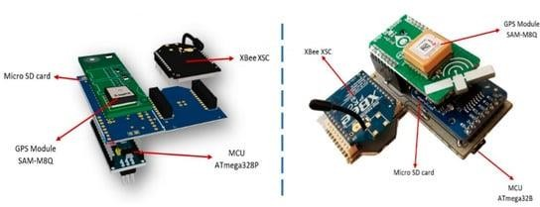

**Figure7.**3Dmodelandpictureofdrifterelectroniccomponents.

* 1. HardwareDevelopment
  2. **SensorandProcessingConsiderations**

FloodMonitoringSystem**WithIoTSensors**

[FloodWarningSystemDefinitionAndTypes](https://www.renkeer.com/flood-warning-system/)

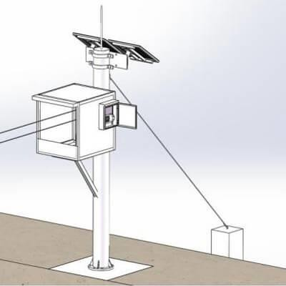In view of the frequency and severity of floods, many technology companiesuse the Internet of Things to propose many solutions and countermeasures.Amongthem, flood monitoringsystems withsensorsarewidelyused.

Dataviewingandanalysis

The data collected by the flood monitoring system is finally transmittedwirelessly to the free [cloud platform](http://en.0531yun.cn/)or the customer’s own platform. Staff cannot only view real-time data by logging in to the platform, but also set alarmvalues and check the working conditions of various sensors through theplatform. Choose a platform that can log in on a computer and view dataremotely through the mobile APP. In this way, the staff can grasp the dataevenwhentheyaremoving,andreactintime.

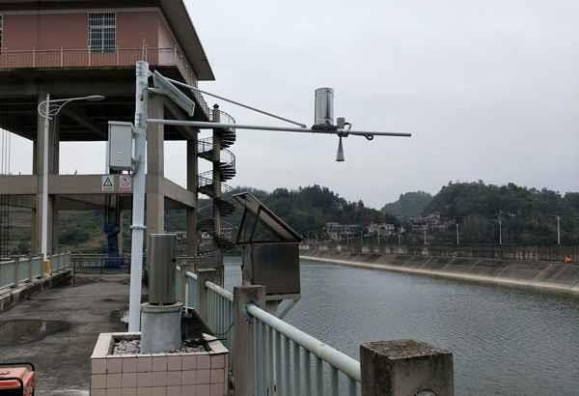

Renkefloodmonitoring system

Technological innovation and digital empowerment are effective ways toimprovetheleveloffloodanddroughtdisasterprevention.Toscientificallyand effectively respond to changes in the natural environment, geologicaldisasters, and flood disasters, Renke has independently developed a floodmonitoring system in response to government requirements. The systemconsists of a data acquisition system, a solar power supply system, an all-weather protective box, a weather observation bracket, a video monitoringsystem, and an environmental monitoring platform. Through the deployment ofsensor collection terminals, intelligent data collection and integrated uploadingare realized, combined with the back-end environmental monitoring platform,the flood prevention and disaster reduction monitoring system is improved,analysis and judgment are strengthened, and warning information is releasedin time to provide comprehensive and comprehensive guarantee for its safeandstableoperation.

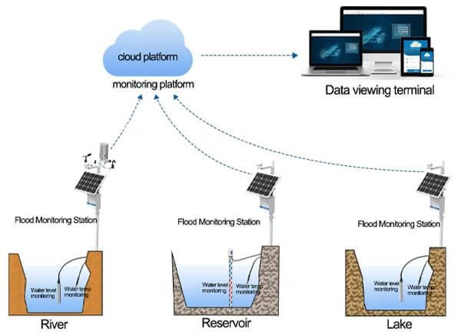

Among them, water level monitoring and rainfall monitoring are the key partsof the flood monitoring system. Through the monitoring of water level, totalrainfall, instantaneous rainfall, daily rainfall, current rainfall and other data, itprovides timely services for the integrated management of floods and waterresources. In addition, it also supports a variety of environmental monitoringterminals such as [temperature and humidity sensor](https://www.renkeer.com/product/solar-radiation-shield/), [wind speed sensor](https://www.renkeer.com/product/polycarbon-wind-speed-sensor/), [winddirection sensor](https://www.renkeer.com/product/polycarbon-wind-direction-sensor/), [illuminance sensor](https://www.renkeer.com/product/illumination-sensor/),[carbon dioxide sensor](https://www.renkeer.com/product/co2-sensor/), and [PM2.5 PM10sensor](https://www.renkeer.com/product/pm-sensor/).

[Tippingbucketraingauge](https://www.renkeer.com/product/stainless-steel-rain-gauge/)

The rain gauge consists of a funnel and a small container fixed on a tippingrod. Before the container is tipped, a certain amount of precipitation iscollected, all the collected water is dumped and the electrical signal is sent tothe data transmitter. Our tipping bucket rain gauge can read the day’s rainfall,instantaneousrainfall,yesterday’srainfall,totalrainfall,hourlyrainfall,last

hour’s rainfall, 24-hour maximum rainfall, 24-hour maximum rainfall period, 24-hourminimumrainfall,and24-hourminimumrainfallperiod.

[Liquidlevelsensor](https://www.renkeer.com/product/water-level-sensor/)

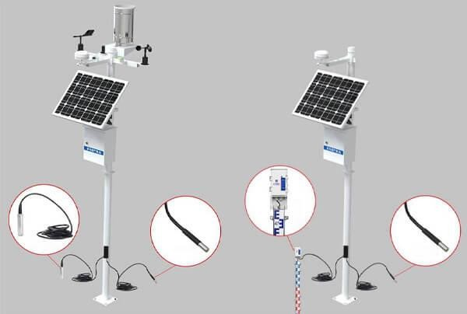The liquid level sensor is a device used to measure the liquid level, whichconverts the height of the liquid level into an electrical signal for output. Themeasuring range can be customized, and it can work in rivers, lakes, andreservoirsforalongtime.

The whole system can be powered by solar energy, with large-capacity leadstorage batteries, and can work continuously for seven days on rainy andcloudy days to ensure the normal operation of the equipment. At the sametime, it supports wireless 4G signal or RS485 signal upload mode, whicheffectively reduces the overall cost of the system, improves system reliability,and is suitable for a variety of outdoor environments. The system is simple toinstall, easy to operate, without wiring, and effectively solves the constructionproblems of no electricity and no network cables in the field. The systemdesign complies with national and industry standards and meets the needs ofnetworking and sharing. It is widely used in hydrological departments for real-time monitoring of hydrological parameters such as rivers, lakes, reservoirs,channels,andgroundwater.

Features of Renke Flood MonitoringSystem

1. **Remotemonitoring**:Thefloodmonitoringsystemcanremotelyviewthe

temperature, humidity, rainfall, water level, water temperature, illuminance,wind speed, wind direction, and other monitoring data in the currentenvironment andthe operatingstatusof thefieldequipmentinreal-time.

1. **Real-time monitoring**: The video image captured by the camerasynchronizes data to the environmental monitoring platform through the videocharacter overlay. Through video monitoring, the current water level, rainfallsituation, and current environmental information can be monitored in real-time,whichisconvenientforremotecontrol.
2. **Over-limit alarm**: When any monitored data exceeds the upper limit set bythe administrator, the platform will send alarm information to the administratorintheformofSMS,phone,email,etc.
3. **Historical data query and analysis**: The flood monitoring system supportsquerying the historical data of one or more water and rain monitoring stationsin the jurisdiction. Select the corresponding site, time range, and data type(hourly data, daily data, monthly data, quarterly data) according to your needsfor query, support data comparison and analysis, and export historical datareportsinPDFandExcelformat.
4. **Data storage**: The weather monitoring host is used in the data acquisitionsystem, with built-in data storage, which can store 520,000 records. When thecommunication fails, the device will automatically store it, and the stored datacanbeuploadedafterthecommunicationisrestored.
5. **Multipleterminalviewing**:The systemsupportsmultiplemethods suchascomputerPC andmobilephone clientstoviewdataanytimeandanywhere.
6. **Large-screen visualization**: Centralized scrolling display of environmentalmonitoring data of each monitoring point, real-time display of the dynamiccurve of water level, rainfall, and other elements, the data is clear andintuitive,whichisconvenient formanagementpersonneltoviewthesystem.